Applications of Deep Learning

Abstract— Deep learning is the latest innovation in the fields of Machine Learning and Artificial Intelligence. Deep learning tries to mimic a human brain, it can intake and process lots of amount of data and also performs complex tasks on them. This report discusses the applications of deep learning and how we can apply it in the near future. We start by introducing deep learning and how it differs from machine learning and then we explore some of its applications in various different fields.

Keywords—deep learning, speech synthesis, self-driving cars, RNN, CNN, face recognition

What is deep learning
Machine learning is a set of algorithms which read data and try to understand them and make intelligent decisions on basis of what they have understood. Deep learning is a subgroup of machine learning[1].Deep learning at its simplest form is automate predictive analysis. In case of traditional machine learning the programmer has to be very specific as to what task the machine should perform. Hence the learning is supervised. Whereas in case of deep learning the learning is unsupervised and the tasks is performed automatically.
Deep learning consists neural networks. Neural networks process information in the same way human brain does. Neural network consists of an interconnected network of tiny processing entities (neurons) working in parallel to perform the task. There are various different models of neural networks available the most famous being RNN (Recurrent Neural Networks) and CNN (Convolutional Neural Networks)[2].Deep learning although requires huge amount of data and training time it is able to give results and accuracy which is on par with the human level and in some cases it has already surpassed human level.
Deep learning has been used since the last 4 decades but it has gained prominence in the last 8-9 years when a deep learning model ALEXNET won the ImageNet challenge 2012 with an error of 15.8 percent which has almost 11 percent lower than the runners up. ALEXNET was based on CNN architecture. After this many new models have been made and since 2012 all ImageNet challenges have been won by Deep learning algorithms
Also, since the last few year GPUs by companies such as NVIDIEA have gotten more powerful and also cheaper and this has sparked interest in deep learning and Data science since the it allowed deep learning models to be trained in a relatively small time.

Why Deep Learning
- In case of deep learning the tasks are performed end–to-end whereas in case of machine learning we have to divide the tasks into various subtasks and program each subtask explicitly. Thus, deep learning is more of a complete algorithm.
- Deep learning takes into consideration many features while training as compared to machine learning [3]. Therefore, the results of deep learning are more accurate although deep learning takes considerably more time to train.
- Deep learning algorithms should be used only when input data size is large, for smaller data sets traditional machine learning algorithms are more preferred.
- Since Deep learning doesn’t need to be programmed explicitly, we can use architecture of model for many uses. For example, Vision, time series, language etc., are using techniques like convolutional neural networks, recurrent neural networks, long short-term memory etc.
- Deep learning has made computer vision possible [1]. Deep learning is used to classify images and not only it is better than traditional algorithms but it is starting to outperform actual humans.
- Although deep learning is better than machine learning but the problem is that it is difficult to choose the topology, hyper parameter and training methods and often it is trial and error based as there is no concrete theory on how to choose them. Also, there is no way of knowing beforehand that whether a particular combination of the above parameters will give the optimum and best result.
- The images below are an example of object detection using machine learning and deep learning. As we can see in case of machine learning all the features have to be extracted by the programmer and the programmer has to explicitly write the algorithm for each feature. Whereas in case of deep learning feature extraction is done by the algorithm itself and it has a greater accuracy as compared to machine learning.

Applications

1)Speech to text using deep learning
Speech can be converted to text using two models

1. Word model -vocabulary is small and the words are modeled on their own
2. Phone model - based on parts of words
Phone model has 2 subparts
1. Context independent -only the subparts are considered
2. Context dependent-subparts along with their neighbors are considered

Traditionally speech to text was done using models such as Hidden Markov model (HMM) and Guassian Mixture Model (GMM).
HMM is a flexible model since it allows addition of unobserved states. But more flexibility doesn’t mean that it will fit the data well and will give accurate results. GMM is used when you have some hidden (non-observable) parameters.
In order to overcome all the shortcoming a new model was created known as DNN-GMM-DMM. But we first need to study the feature extraction methods

1.1 Feature Extraction [4][5][6][7]
SR no | Feature Extraction | Advantages | Disadvantages
1 | Linear Predictive coding | It is useful for modelling vowels which are periodic but not for nasalized vowels  It is accurate and also the computation time is also good. It is mostly used for encoding at low bit rate | However, it cannot distinguish vowels with similar sounds.
2 | Mel-frequency cepstrum (MFFCs) | MFFC tries to mimic the working of the human ear by using a series of mathematical Formulas and functions  MFFC is not very complex to implement and also it has a very high accuracy | MFFC doesn't work well when there is background noise  Also performance may be affected by the number of filters used.
3 | RASTA filtering | Unlike MFFC it can work in noisy environment It doesn't depend on the choice of microphone nor does it depend upon the distance of mouth relative to the microphone. It can capture low modulation frequencies | It requires silence to detech each utterance of a word
4 | Principal component Analysis (PCA) | It is a used to reduce dimensionality of data while keeping the variance same | it depends upon the scaling of data and there is no way to know what way is best to scale the data to obtain optimum results.

Comparison of speech models [8][9][10]
SR No | Model Name | Advantages | Disadvantages [4]
1 | Hidden Markov model (HMM) | • HMM is very rich in mathematical structure and hence can form the theoretical basis for  use in a wide range of application.  • HMM model, when applied properly work well in practice for several important application. | • Trial and error method for choosing a model topology.  • The number of parameters needed to set up an HMM is huge.  • Amount of data required to train an HMM is very large.  • The assumption that successive observations are independent.  • The Markov assumption itself
2 | Guassian Mixture Model(GMM) | • The GMM algorithm is a good algorithm to use for the classification of static parameters  • GMMs are well known for their ability to represent arbitrarily complex distributions into clusters.  •GMM-based classifiers are highly effective with widespread use in speech research, primarily for speaker recognition, de noising speech features, and speech recognition. | •GMM can't work with problems of high dimensionality.  •Isn't suitable for temporal patterns.  •the number of mixture models to be set up for the algorithm to fit the training dataset
3 | Long short-term memory (LSTM) RNN | As we increase the number of hidden layers the error decreases and the accuracy increases, also they are immune to gap lengths in word sequence as compared to HMMs. | Although as compared to deep Feed forward networks, performance of RNN is dull.

The main issue with normal methods is that it cannot distinguish hello from Heelllooo. Hence deep learning is used. But we cannot directly feed the sound waves to the neural network. Sound waves can be expressed in one dimension and at each particular time it has an amplitude associated with it. To make it easier for the computer to understand we convert the speech to numbers. This can be easily done by noting the height of the wave at equally spaced points. This process is known as sampling. For human voice sampling rate of 16 kHz is enough to cover all the frequency
Even after sampling the sound samples may contain different kinds of sounds and to make it easier for the neural network to understand we break the sample into the its component parts by a mathematical process called Fourier Transform

[11]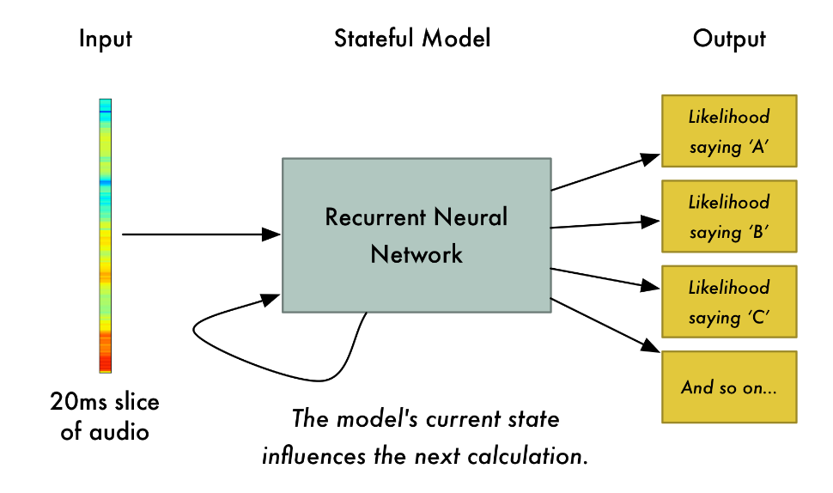
We feed the small slices of audio sample to the RNN. For each audio slice it will try to recognize the letter corresponding to the sound. In case of RNN it has a memory that influences the future predictions. If the RNN has interpreted the sound as HEL till now then the mostly likely next two letters will be LO and not PQR. So, the memory of the neural network helps in making more accurate predictions
The accuracy of such deep learning models depends on the training set used and it increases over time as it is tested more and more. Currently Deep learning models are being used with accuracies up to 97%.

Comparisons of different APIs using Deep Learning
Sr No | API | Advantages | Disadvantage
1 | Google Cloud Speech API | • Support more than 110 languages  • Can work in real time  • Stable against side noises | •Only 60 minutes free per user  After 60 minutes (0.006 USD per 15 seconds)
2 | IBM Watson | • provide customization for particular  acoustic condition | • few language supported and even  fewer supported for the customization of acoustic model
3 | Amazon Transcribe | • Automatically adds punctuation marks  and does text formatting  • Best feature is that it supports telephony audio  • Adds timestamp for each word | •The feature which labels different  features is not accurate as of now

2.Deep learning for Self Driving Cars[12][13]
Nvidia has created a deep learning-based system which is known as PilotNet which tries to mimic the behavior of human drivers and can be used as self-driving car Controller.

2.1 How does PilotNet Work
PilotNet is a CNN which is trained to output the Steering angle value based upon the input image. For the training set, a camera was placed in front of a car which an experienced human driver drove. At regular intervals the camera took photos and at the same time a sensor placed on the steering wheel recorded the steering angle. The steering angle is expressed as (1/r) where r is the turning radius of the vehicle.
The network consists of 9 layers, including a normalization layer, 5 convolutional layers and 3 fully connected layers. Each image is converted to YUV plane and then fed into the network. The first layer does the process of normalization and it is coded explicitly and hence it is not always adjusted to the learning process. The five convolutional layers are followed with three fully connected layers that output the value of the inverse turning ratio.
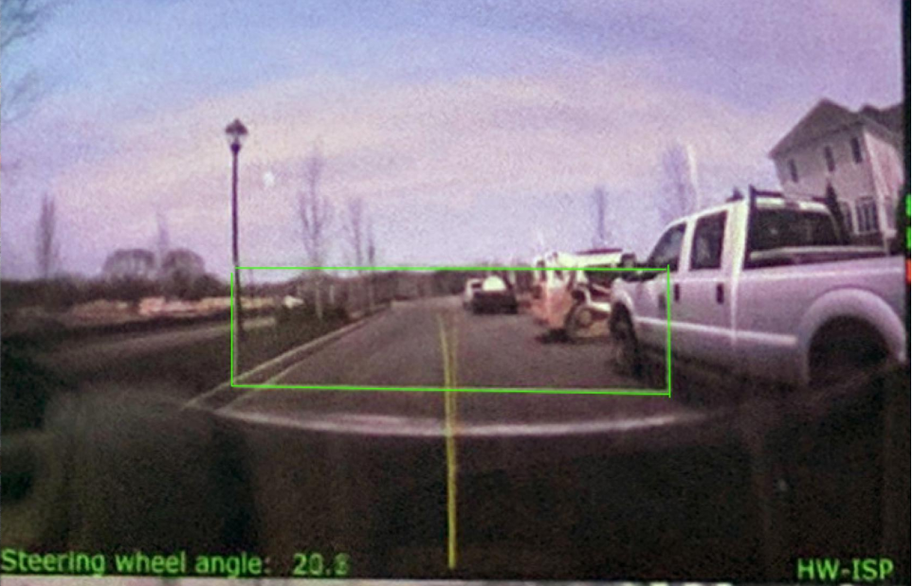
[12]

2.2. How does PilotNet detect the Salient Objects?
Salient Objects are the objects which would require the car to respond accordingly in order to avoid the crash. Salient Objects can be anything from pedestrians, other cars, dead ends, curves in road, animals, etc.
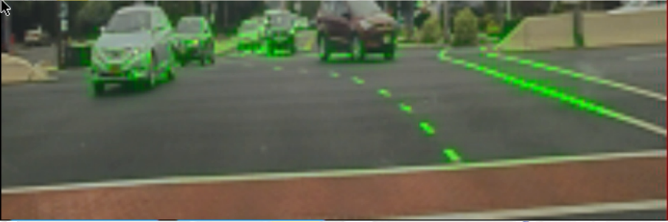
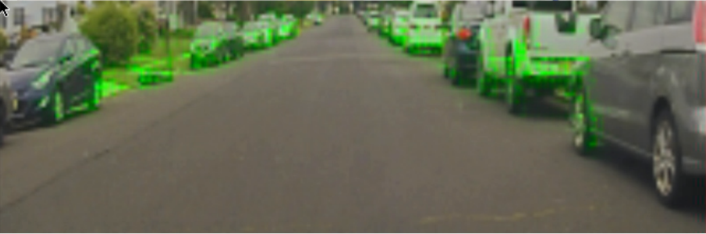
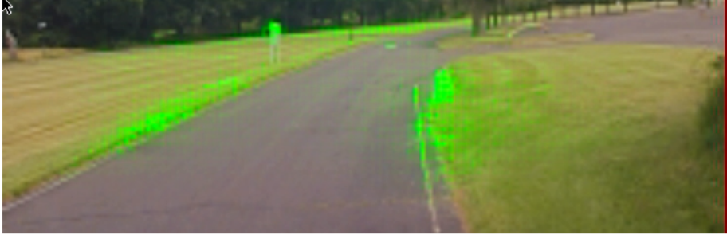
[13] Examples of various saliant objects

2.3 How does the Network the analysis the situation after detecting the Salient Object
After detecting the objects, the network verifies whether the object would produce an effect on the steering angle. To check that, the images are divided into 2 classes. Class 1 consists of all regions that would produce a significant difference in the steering angle. Class 2 consists of regions left over after removing all the regions of class 1 from the original image.
If the objects found indeed have a significant effect on the output steering angle then to verify, we would create a new image in which we would uniformly translate the pixels in class 1 while keeping the position of class 2 pixels as it is. We feed this new image to the PilotNet, and we should expect a big change in the steering angle output. But if we instead transfer the class 2 pixels while keeping those in class 1 fixed, we would get minimum change in the PilotNet’s Output.

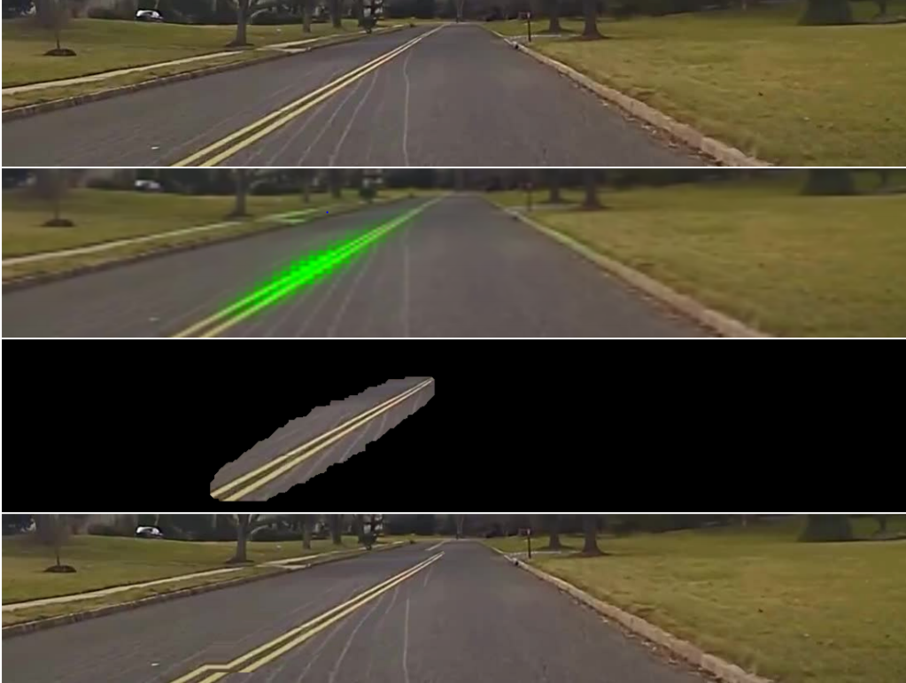
[12]

In the example above PilotNet detects the white line which separates the road as a salient object and put its pixels in class 1. It then creates a new image in which the pixels are shifted by some predefined amount while keeping the rest of the pixels as It is. When the new image is fed into the Piloted, A drastic change in steering angle will be observed. Which means the object will not produce an drastic effect on the steering angle.
2.4 Conclusion
PilotnNet makes the steering decisions based on the regions of the inputted images. It can identity which regions/objects are important and will ignore the irrelevant regions Although PilotNet can detect salient objects just like humans, but it fails to recognize features which are hard to code by humans such as bushes on the edge of the road and also vehicles which do not have a typical shape.

3. Deep Learning in Face Recognition [14][15]
A facial recognition system is capable of identifying a person from a photo or video source. There are many faces in which faces are identified, but the most common method is to compare facial features from the given source to the faces in the database. The most important use of face recognition is in security systems. Although it provides less accuracy than the traditional security systems such as iris recognition and fingerprint recognition, it has an advantage of being a contactless process.
FaceNet is a complete algorithm which can be used for 3 purposes – face verification, recognition and clustering. Face verification is used to know if it’s the same person, recognition is used to know the identity of the person and clustering is find the common people all the people.
FaceNet is an example of CNN and it trained to enhance the embedding process and unlike the previous approaches it does not make use of bottleneck layer. Embedding is the process by which we represent the input in a better and convenient form. Bottleneck layer is a layer which has a smaller number of nodes as compared to the other layers and it is used to express the input in lower dimensions. In the previous approaches the classification layers were used and trained over the input data (known faces) and then this was passed on to the bottleneck layer which would then generalize. However, this process was very inefficient.
3.1 How does Facenet work?
The embedding used is the Euclidian embedding. The squared L2 distances in the space directly correspond to the similarity index. The distances for same person will be same and in that way we will be able to identify/recognize the person.
Facenet presents the output in from of 128D embedding using Large Margin Nearest Neighbour (LMNN). It is based on triplet-based loss function. The triplet consists of 3 thumbnails out of which 2 are matching and one is not matching and the loss function tries to distinguish the matching pair by the non-matching pair. The thumbnails are photos of the face without any two dimension or three-dimension alignment.
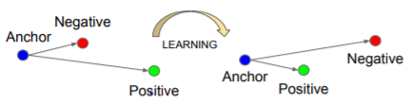[16]

The triplet losses tries to minimize the distance between a A and P and also tries to maximize the distance between A and N. where A is anchor ,P is positive and N is negative.

3.2 Models Used
In case of Facenet two type of models can be used –
- Zeiler&Fergus model – it consists of lot of interwoven layers and non- linear activation and max pooling layers. Also several 1*1*d layers were added to increase accuracy.
- Inception model which won the ImageNet challenge in 2014.This model uses both convolutional layer and pooling layers together and their results are concatenated.
Both of the above methods can reduce the number of parameters by 20 times
3.3 Factors Affecting Accuracy
There are several factors which affect accuracy-
3.3.1 Image Quality
On decreasing the image quality, the model shows surprising results and also gives acceptable performance. E.g. For 65,536 pixels the accuracy is 86.4% whereas for almost a third of pixels 25,600 the accuracy achieved is almost 85.7%.
3.3.2 Number of dimensions in Embedding
On the increasing the number of dimension the validation rates stays constant.
3.3.3 Amount of Training Data
On increasing the amount of images the accuracy increases. E.g. for 2,600,000 images the accuracy is 76.3% but for 100 times the images the accuracy is 86.2%.
3.4 Conclusion
Face Recognition has many applications. In some major events it is used to identified already known criminals and is used to segregate them. It is used now a days In smartphones as means of opening the lock without touch. It is used by big companies such as Facebook to tag the people in the photos automatically. FaceNet is a complete end to end model which can perform identification, recognition and clustering. On the LFW dataset, FaceNet achieves a validation rate of 99.63%.

Conclusion
In sum, deep learning has many applications out of which some were listed above. Deep learning certainly can improve the performance of many existing processes and goes a long way in automating the processing. Deep learning can perform tasks which were deemed impossible by the previous standard algorithms. In future Deep Learning is surely going to touch every aspect of our lives.

References

[1] Goodfellow, Ian, Yoshua Bengio, and Aaron Courville. Deep learning. MIT press, 2016.
[2] Sarle, Warren S. "Neural networks and statistical models." (1994).
[3] LeCun, Yann, Yoshua Bengio, and Geoffrey Hinton. "Deep learning." nature 521.7553 (2015): 436.
[4]Chakraborty, Chandralika, and P. H. Talukdar. "Issues and limitations of HMM in speech processing: a survey." International Journal of Computer Applications 141.7 (2016): 975-8887.
[5]Dave, N., 2013. Feature extraction methods LPC, PLP and MFCC in speech recognition. International journal for advanceresearch in engineering and technology, 1(6), pp.1-4.
[6]Narang, Shreya, and Ms Divya Gupta. "Speech feature extraction techniques: a review." International Journal of Computer Science and Mobile Computing 4.3 (2015): 107-114.
[7]Guyon, I., Gunn, S., Nikravesh, M. and Zadeh, L.A. eds., 2008. Feature extraction: foundations and applications (Vol. 207). Springer.
[8]Jelinek, F., 1997. Statistical methods for speech recognition. MIT press.
[9]Rabiner, L.R., 1989. A tutorial on hidden Markov models and selected applications in speech recognition. Proceedings of the IEEE, 77(2), pp.257-286.
[10]Garg, Anjali, and Poonam Sharma. "Survey on acoustic modeling and feature extraction for speech recognition." 2016 3rd International Conference on Computing for Sustainable Global Development (INDIACom). IEEE, 2016.0
[11]medium.com/@ageitgey/machine-learning-is-fun-part-6-how-to-do-speech-recognition-with-deep-learning-28293c162f7a
[12]Bojarski, Mariusz, et al. "Explaining how a deep neural network trained with end-to-end learning steers a car." arXiv preprint arXiv:1704.07911 (2017).
[13]Danwei Wang and Feng Qi. Trajectory planning for a four-wheel-steering vehicle. In Proceedings of the 2001 IEEE International Conference on Robotics & Automation, May 21–26 2001.
[14] Schroff, F., Kalenichenko, D. and Philbin, J., 2015. Facenet: A unified embedding for face recognition and clustering. In Proceedings of the IEEE conference on computer vision and pattern recognition (pp. 815-823).
[15] Schreiber, A.C., Rousset, S. and Tiberghlen, G., 1991. Facenet: A connectionist model of face identification in context. European Journal of Cognitive Psychology, 3(1), pp.177-198.
[16]https://medium.com/@vinayakvarrier/building-a-real-time-face-recognition-system-using-pre-trained-facenet-model-f1a277a06947

